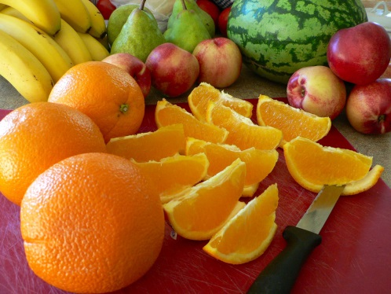
School Name
Insert school logo
CANTEEN MENU – insert term and year
Insert canteen manager name, contact details, ordering process etc.

RECESS MENU
A selection of these delicious recess items available everyday

Item | Price
 | $

LUNCH MENU
All of our sandwiches, rolls, wraps and toasties are made fresh daily, exactly the way you like them with wholemeal or multigrain bread

Item | Sandwich | Roll
 | $ | $
Wraps | Half | Full
 | $ | $

HOT FOOD
Insert a list of hot food e.g. toasted sandwiches, pasta meals, hot rolls etc.

tem | Price
 | $
DAILY SPECIALS

If you feel like something special choose from our tasty daily specials below

MONDAY

TUESDAY

WEDNESDAY

THURSDAY

FRIDAY

DRINKS
Rehydrate with water or one of our other drinks

Water 600mL $
Plain milk 300mL
Flavoured milk 375mL
Insert flavours
Fruit juice 250mL
Insert flavours

AFTER LUNCH TREATS
Add a treat to you day from our yummy after lunch menu

Canteen tip

