Insert school logo

XX School

Healthy Food and Drink policy

Instructions for using this template

Compliance with the Department of Education’s Healthy Food and Drink in Public Schools Policy requires schools to have a written Healthy Food and Drink policy. At an operational level, a customised policy helps to bring about and sustain change specifically addressing the needs and aims at your school.

This template is editable, allowing you to make changes as required. Throughout the document, you will find ‘red text’ where information can be inserted, edited and/or removed. There are also prompts for additional information/references and instructions shaded in grey (such as this text box) that should be removed when editing.

You will also notice reference to the Green, Amber and Red categories of the ‘traffic light system’ in this template. More information about the traffic light system can be found in the appendix or visit www.waschoolcanteens.org.au

Policy statement

We value the health and wellbeing of our students, staff, volunteers and parents. Our school aims to create a healthy, positive, safe and empowering food environment.
(The policy statement can be customised to suit your school)

Background

Our school is committed to providing healthier food and drinks for the school community and complying with the Department of Education’s Healthy Food and Drink in Public Schools (HFD) policy (see Appendix 1). The Australian Dietary Guidelines and the Australian Guide to Healthy Eating establish the basis for a healthy eating approach. A key message of the guidelines is to enjoy a wide variety of nutritious foods every day.

XX School’s Healthy Food and Drink policy:
- is underpinned by the Australian Dietary Guidelines, the Australian Guide to Healthy Eating and the Health Promoting Schools Framework
- is consistent with the Department of Education’s HFD Policy
- applies to classroom rewards, cooking activities, school camps and excursions
- applies to all operators of a canteen/foodservice including the parent body, schools and school boards, external contractors and local caterers/shops that provide a food service to the school.

Whole school approach

Our school is well placed to support healthy eating as it provides the opportunity for regular access to a ‘captive audience’ and has a vital role to play in helping to reduce the worldwide epidemic of obesity. Canteen/food service staff, parents, school staff (teaching and non-teaching) and health professionals who work with schools can be positive role models and champions to endorse health promotion in schools.

XX School and the canteen/food service will work together with the school to support healthy eating by adopting a whole school approach. Consistent messages can be promoted through the curriculum, social and physical environments.

XX School will adopt a whole school approach to promote healthy lifestyles through the following: (delete and add to the following list as required)
- school breakfast program
- healthy catering at meetings and events
- daily fitness programs
- communication on healthy eating and/or other health promoting messages e.g. whole of school community newsletter; internal staff communications; schools noticeboards and classroom announcements
- non-food related fundraising initiatives
- fundraising initiatives which promote healthy eating and/or physical activity such as lapathons
- whole school staff (teaching and non-teaching) health and wellbeing initiatives e.g. professional development workshops and training about food, nutrition and broader health messages
- other school based health promotion programs, such as Crunch & Sip, school kitchen gardens and Jump Rope for Heart.

Role of XX School’s canteen/food service

Our canteen/food service will:
- comply with the Department of Education’s HFD policy
- provide a food service to the school community that:
  - meets their nutritional needs
  - promotes healthy food
  - prepares and stores food in a safe manner
  - is part of a whole school approach
  - is affordable and financially sustainable.
- reinforce nutrition messages being taught in the classroom by modelling healthier food and drink choices that are tasty, interesting and affordable. This can support students to make informed decisions about their health and wellbeing by influencing food choices by students at school and in the wider community, and help to equip students with the knowledge to continue to make healthy choices throughout their adult lives.

XX School’s canteen/food service committee

XX School will have a canteen/food service committee, with representation from the whole school community, including where possible students, parents and teachers. The committee will participate in the decision making process for the canteen menu, pricing, purchasing and maintenance of equipment etc. The canteen committee will follow the terms of reference as agreed by the parent body or school/school board.

Canteens operated by the P&C may form a canteen committee as a sub-committee of the P&C. Visit the WASCA website for draft Terms of Reference.

Canteen menu planning (see Appendix 2)

XX School’s canteen/food service menu will:
- include a minimum of X% GREEN menu choices
- include a maximum of X% AMBER menu choices
- not include food and drinks categorised as RED as they do not meet specified minimum nutrient criteria
- limit savoury commercial AMBER products to no more than twice per week.

Healthy eating at XX School will be supported by:
- changing the menu according to the summer and winter seasons
- having available every day and promoting a wide range of the foods that should make up the majority of a healthy diet (GREEN)
- offering a range of foods and taking into consideration Australia’s multicultural society.

Skills and knowledge

XX School recognises that compliance with the Department of Education’s HFD policy requires the canteen/food service supervisor and/or employer (e.g. parent body representative) to undertake Traffic light training provided by the Western Australian School Canteen Association Inc. (WASCA).
- The canteen/foodservice staff and/or employer will undertake Traffic light training for canteens in a timely manner
- Canteen/food service staff and other school stakeholders at will be encouraged to participate in additional professional development and training. For example, canteen network meetings and financial management training provided by WASCA
- School staff and health professionals that work with our school (e.g. Community health Nurse) will be encouraged to complete the Traffic light trianing for school staff and health professionals.

Food safety and hygiene

XX School will comply with the Food Act 2008 (WA) and the Food Regulations 2009, including:
- Our canteen/foodservice will apply for registration with the local council as a food business (a fee may be applicable)
- Our school will notify the local council prior to conducting a charitable or community event involving food (i.e. a cake stall or sausage sizzle)
- Information on these requirements will be sought from the local council prior to any school function, i.e. cake stall or sausage sizzle, where food will be provided.

It is a requirement that all canteen/food service staff and all volunteers at XX School must:
- comply with the HFD policy and complete FoodSafe® Food Handler Training program or its equivalent. The training must be completed in a timely manner, preferably prior to commencement
- wear hats, hairnets and aprons which will be provided by the canteen/food service
- not sell (or provide) foods made at home or brought in by parents/students from a commercial supplier through the canteen/food service
- prepare, cook, transport and serve food in such a way as to retain nutrients and to minimise bacterial contamination and growth.

Occupational health and safety

The canteen/food service at XX School is a workplace and will comply with the Occupational Safety and Health Act 1984 and Occupational Safety and Health Regulations 1996. The Department of Education has a number of policies and procedures related to health and safety. Including:
- All canteen/food service staff and volunteers to be made aware of evacuation procedures in case of fire or other emergency
- All canteen/food service staff and volunteers to wear enclosed footwear. Shoes with heels or open sandals are not acceptable
- Students and teachers are not permitted to enter the canteen premises during normal trading hours unless it is part of a supervised school curriculum activity
- Only canteen/food service staff and volunteers rostered for duty may enter the canteen premises during normal canteen opening hours
- Children (e.g. children of volunteers) are not permitted in the canteen during normal canteen opening hours.

Allergy and anaphylaxis management

Food allergen management is part of food safety and school canteens, like all food service providers, must comply with the legislation. The law requires you to provide accurate information when a customer asks about allergens in the food you are serving. Further information is available from www.foodallergytraining.org.au. An Allergy Aware Checklist can be downloaded for free from the resources section of www.foodallergytraining.org.au

Everyone working in the canteen/food service (paid and volunteer staff) needs to be aware of the risks food allergies pose. It is important to:
- know how to identify and manage food allergens
- know what is in your food so that you can provide accurate information about foods a customer is allergic to
- know how to respond to enquiries from customers with food allergies.

ASCIA Action Plans will be displayed in the canteen at XX School in clear view of staff working in the canteen only (not customers).

Canteen/foodservice staff at XX School will be encouraged to complete All about Allergens online training available free at https://foodallergytraining.org.au/

Further canteen management issues are covered in Appendix 3.

Distribution of the policy

A current copy of the Department of Education‘s HFD policy and XX School’s Healthy Food and Drink policy will be on permanent display in canteen/food service.

A copy of the current XX School’s Healthy Food and Drink policy (signed and dated) will be provided to all canteen/food service committee members at the first committee meeting following the parent body Annual General Meeting and/or school board meeting. This policy shall not be added to, or amended, except at the Annual General Meeting of the parent body, or a special meeting thereof (called for that purpose); and then only with the approval of the majority of those present and entitled to vote

Renewal of the policy

This policy will be reviewed annually by XX School’s canteen/food service committee and suggested amendments will be forwarded to the parent body/school board and Principal.

Endorsement

We the undersigned, hereby certify that this policy was adopted by
(insert details of principal and/or relevant meeting of the parent bod or school board) on (insert date).

Insert relevant signatures include role, examples provided

Principal

________________________________________________

President (Parent body) or Chairperson (School Board)

________________________________________________

Chairperson Canteen Committee (if applicable)

________________________________________________

Appendix 1

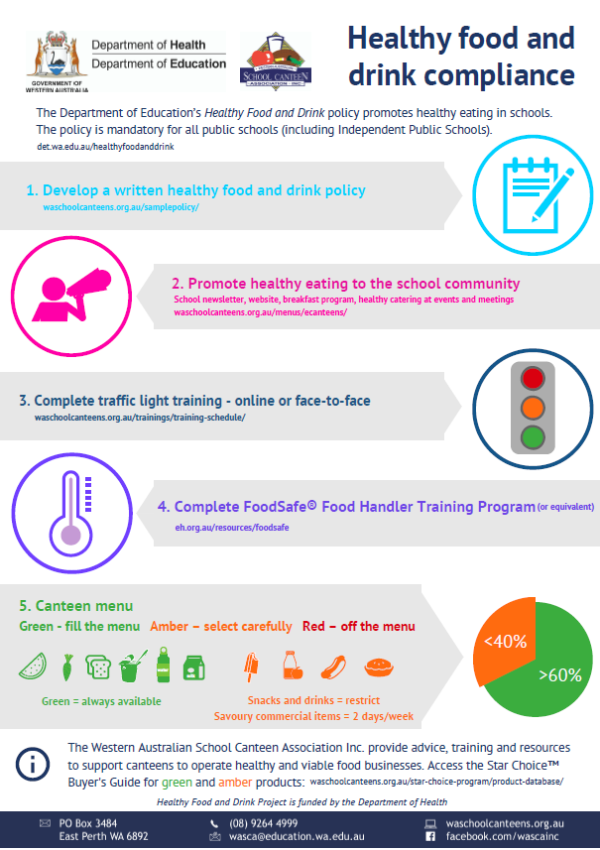

Appendix 2

Department of Education’s Healthy Food and Drink policy
What’s on the menu

Green food and drinks  - Cereal foods — wholegrain cereals, pasta, noodles, rice, cous cous, quinoa  - A variety of bread types including wholegrain/ wholemeal  - Vegetables and legumes e.g. stuffed potatoes, corn-on-cob, baked beans, 4 bean mix, garden salads, potato salad, coleslaw (using reduced fat dressings )  - Fruit, fresh and frozen, whole, fruit salad, sliced fruit  - Fruit canned in natural juice  - A variety of sandwich/roll fillings, preferably served with salad e.g.  - egg  - reduced fat cheese  - tuna, canned in spring water or brine  - lean meats i.e. roast beef  - yeast spreads  - hummus  - Lean meats, fish, poultry  - Meals#, especially those with vegetables e.g. pasta bake, curry and rice, frittata, soup, sushi, rice paper rolls  - Reduced fat dairy products  including:  - plain milk  - flavoured milk (375mL or less)  - cheese  - plain and flavoured yoghurt  - Plain water  - Plain mineral water | Amber food and drinks  - Savoury breads such as garlic, herb and pizza bases  - Reduced fat pastry items#  - Frankfurts and sausages for hot dogs and/or sausage sizzles#  - Savoury commercial products, e.g. fish, chicken, potato portions, pizza#  - Hamburger patties#  - Processed meat e.g. ham, skin-free processed chicken  - Assorted cakes/biscuits or muffins#  - Sweet and savoury snack foods#  - Plain dried fruit  - Ice creams and icy poles#  - Reduced fat flavoured milk  (more than 375mL & less than 600mL)  - High schools only: reduced fat coffee flavoured milk (375mL or less)  - Full fat dairy products e.g. plain milk, yoghurt, cheese  - Full fat flavoured milk (375mL or less)  - 99% fruit juices (250mL or less) and no added sugar  - Dairy desserts# e.g. reduced fat custard, ice cream and mousse (milk/milk alternative listed as first ingredient)  NOTE: Reduced fat dairy recommended for children over the age of 2 years | Red food and drinks  - Full-fat pastry items  - Deep fried food  - Sweet sandwich fillings e.g. jam, honey, confectionery sprinkles  - High fat meats e.g. polony and salami  - Confectionery e.g. chocolate, liquorice, cough lollies, jellies  - Sweet or savoury snack items that do not meet the criteria e.g. potato chips  - Soft drinks, cordial, sports drinks, energy drinks  - Reduced fat flavoured milk  (more than 600mL)  - Reduced fat coffee flavoured milk drink (more than 375mL)  - Full fat flavoured milk (more than 375mL)  - Chocolate coated ice-creams  - Jelly; fruit with jelly  - Croissants, cream or iced buns/cakes, doughnuts, sweet pastries, slices  - Fruit juice (more than 250mL) and/or with added sugar or sweetener  - Water flavoured with fruit juice, sugar and/or sweetener

Appendix 3

Canteen management issues

1. Employment
- The canteen/food service supervisor shall be employed in accordance with the current legal requirements pertaining to minimum conditions, or a salary negotiated and approved under an enterprise agreement (minimum award conditions must apply, including superannuation)
- The canteen/food service will comply with equal opportunity guidelines for employment
- The canteen/foodservice supervisor shall have a written job description agreed to by the Canteen Committee and/or parent body and canteen supervisor
- The canteen/food service supervisor shall be appointed by, and if necessary, dismissed by the Executive of the parent body in consultation with the Canteen Committee and XX School’s Principal.

Note: if the canteen/food service is outsourced to a private contractor, please seek advice and guidance on the appropriate process from the Department of Education.

3. Pricing policy/profits
- The primary objective of XX School’s canteen/food service is to provide a nutritious food service
- The canteen/food service may endeavour to provide a financial contribution towards resources for all students in the school after its financial obligations have been met (e.g. for maintenance of facilities and equipment, new equipment, professional development and training)
- Profit making by XX School’s canteen/food service will not be made at the expense of providing students with less healthy choices (AMBER)
- The average mark-up on healthy (GREEN) items shall be lower than that applied to less healthy (AMBER) products.

4. Canteen/food service equipment
- The canteen/food service committee shall provide essential, safe equipment and ensure that it is well maintained, in good repair and used according to the appliance directions
- The canteen/food service committee shall report to the Principal any structural defect(s) within the canteen.

5. Gifts/concessions
- All discounts, allowances, complimentary articles, gifts, concessions and the proceeds thereof from any supplier of goods or services, directly or indirectly, to the canteen shall remain the property of the canteen and be properly recorded and later accounted for at the time of stocktaking. Public school canteens must comply with Department of Education policies, including the Financial Management in Schools Finance and Accounting policy.

GREEN menu choices must make up a minimum of 60%. Source: Department of Education‘s HFD policy
AMBER menu choices must not exceed 40%. Source: Department of Education‘s HFD policy
Source: Department of Education‘s Healthy Food and Drink policy
Source: Department of Education‘s Healthy Food and Drink policy

