School community links
To ensure compliance with the Department of Education’s Healthy Food and Drink Policy, canteens are required to link with the school community. An effective strategy to do this is publishing information via the school newsletter.
Putting a small article together is not a task that everybody feels comfortable with, so we have developed relevant, interesting snippets that schools can easily print/submit for their school newsletter. This is a great way to keep the school community informed about what is going on in the school canteen and provide information to parents, students and staff about health and nutrition.
Some of the snippets include images. These are simply form clipart in Microsoft Word and freely available.
Why are small serves of flavoured milk classified as GREEN?
Dairy foods are a great source of calcium and protein for growing bodies and are essential in a healthy diet. Unfortunately many Australians do not consuming adequate amounts of dairy (or alternatives e.g. soy) with 73% of females and 51% of males not meeting their daily requirement.
Whilst reduced fat plain milk is the optimum choice for all students many simply don’t like plain milk. Flavoured milk is a great alternative as it made with reduced fat milk and is high in calcium.
- Reduced fat plain milk in any size is classified as Green
- Reduced fat flavoured milk less than 375mL is classified as Green
- Reduced fat flavoured milk great than 375mL is classified as Amber
Source: National Nutrition and Physical Activity Survey, 2011-12.

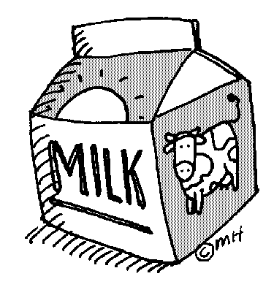

What is the Traffic light system of categorising food and drinks?
Our school has implemented the Department of Education’s Healthy Food and Drink policy.
This means our canteen uses the ‘traffic light’ system of categorising food and
drinks based on their nutritional value:
- GREEN food and drinks fill our canteen menu. They are a good source of nutrients and contain less sugar, salt, excessive kilojoules and saturated fat
- AMBER food and drinks should be selected carefully. They have some nutritional value and contain moderate levels of added sugar, salt and saturated fats
- RED food and drinks are off the menu at our canteen. They have no or very little nutritional value and can be high in added sugar and salt, saturated fat and excess kilojoules.
For more information visit http://www.det.wa.edu.au/healthyfoodanddrink/detcms/portal/

Published October 2016

Why doesn’t our school canteen sell soft drink and other high sugar drinks?
The Department of Education’s Healthy Food and Drink Policy classifies sugar-sweetened drinks and/or artificially sweetened drinks that are high in kilojoules and low in nutrients RED. This means that they are not permitted for sale.
Examples include soft drinks, sports drinks, cordials, energy drinks, iced teas,
high caffeine drinks, flavoured mineral waters and fruit juice containing
less than 99% fruit. Our school has a wide range of GREEN drinks and some
AMBER drink options that will keep your child hydrated, happy and healthy!

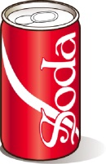

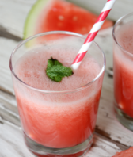
Why are canteens permitted to sell iced slushies?
The slushies that are sold in school canteens are not the same as those sold in
other food outlets and petrol stations.
The slushies in our canteen are categorised as Amber. They are made from 99% fruit juice. As with any Amber menu item they should be selected carefully. Our slushies are only sold in small sizes of 200mL. Whilst water is the best choice for hydration, our fruit juice slushies provide a cool treat in summer after lunch.

The Amber category
Items classified as Amber on the school canteen menu must be limited by either their portion size or their availability. Savoury commercial items such as hot dogs, hash browns, chicken nuggets, pies and sausage rolls should not be available more than twice per week.

Other Amber items, such as small fruit juices, small fruit muffins and ice creams can be sold every day however, they need to be restricted in some way, this is why we only
sell these items at recess or lunch only, not both.

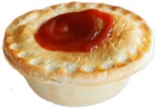

Policy compliance
Our canteen is compliant with the Department of Education’s Healthy Food & Drink Policy. We promote a menu that is has __% GREEN choices, we have a comprehensive policy and our staff have completed Traffic light training and Food Safety and Hygiene training.
We are always looking to improve our canteen so if you have any suggestions for what you would like to see more or less of, please leave a note in the ‘suggestion’ box located at the serving window!

What are the Australian Dietary Guidelines?
The Australian Dietary Guidelines provide up-to-date advice about the amount and types of foods that we need to eat for health and wellbeing and are based on scientific evidence and research. One of the guidelines is to enjoy a wide variety of nutritious foods. This means eating from the five food groups everyday:
- vegetables - a wide variety of different types and colours including legumes and beans
- fruit – fresh or tinned in juice
- grains (cereal) – preferable wholegrain/hi fibre such as breads, cereals, oats, quinoa, barley and rice
- lean meats and poultry, fish, eggs, tofu and nuts
- milk, yoghurt, cheese; preferably reduced fat; or alternatives
e.g. soy milk fortified with calcium

The guidelines also encourage us all to drink plenty of water!
The Healthy Food and Drink Policy that we follow
in the canteen is based on these guidelines. This
ensures we are providing students with a nutritious,
healthy and balanced menu.

For more information visit www.eatforhealth.gov.au

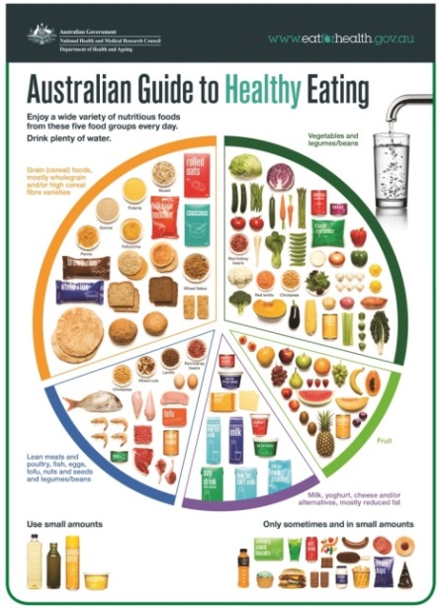

How much is a ‘serve’ according to the Australian Guide to Healthy Eating?
As parents we’ve all had it drummed into us that we need to be eating 5 serves of vegetables and 2 serves of fruit every day for good health. So how much is a serve of fruit or vegetables?
One serve of vegetables = 75g
School aged children 4-18 years require 4 ½ - 5 serves per day
- 1 cup of green leafy or raw salad
- ½ cup cooked green or orange veg (broccoli, carrot, pumpkin, peas)
- ½ cup sweet corn
- 1 medium tomato
- ½ cup cooked, dried or canned beans, peas or lentils
- ½ medium potato
One serve of fruit = 150g
School aged children 4-18 years require 1 ½ - 2 serves per day
- 1 medium apple, banana, orange or pear
- 2 small apricots, kiwi fruits or plums
- 1 cup diced or canned fruit (no added sugar)
- 30g dried fruit – 4 dried apricot halves, 1 ½ tablespoons sultanas

For more information see
www.eatforhealth.gov.au

YES, breakfast is the most important meal of the day!
- One in four Australian children leaves home without breakfast due to no time, no food or not being hungry
- Skipping breakfast can mean that children potentially feel tired, irritable and can have trouble concentrating on lessons
- Breakfast means to ‘break the fast’, it is important to refuel the brain and body
with healthy choices
If time is an issue then try these ‘On the go’ breakfast ideas:
- Tub of yoghurt
- Piece of fruit
- Breakfast smoothie

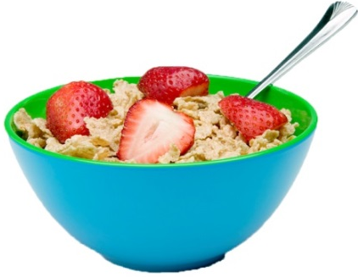

Muesli bars – a lunchbox staple
The muesli and fruit bar aisle of any supermarket can be a minefield, especially if you have taken your children along for the shopping trip! Many bars are energy dense and provide very little nutritional value. Here are some tips to help you make a healthier choice:
- Avoid bars that are dipped in chocolate or contain choc chips
- Avoid bars that contain confectionary i.e. those topped with ‘yoghurt’
- Look for a bar that contains fruit rather than just cereals
- Avoid fruit leather or straps – these are no good for children’s teeth – choose a piece of fruit instead
- Restrict muesli bars to once a week as a treat
- Check your school allergy policy before sending a muesli bar that contains nuts!

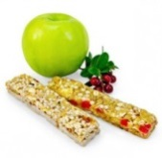

Smart snacks

Snacks are really important for growing bodies. Our children need snacks to ensure they keep up their energy and concentration levels throughout the day. Choose snacks that are low in fat, added sugar and salt as well as being high in nutrients. Our canteen has lots of yummy GREEN rated snacks available. Plus here is a list for you to try for those after school ‘hunger games’.

The top 10 snacks for healthy bodies and healthy minds:
- Fresh fruit
- Chopped raw vegetable sticks (serve them dip or salsa)
- Fruit smoothies or milkshakes
- Small tin of baked beans
- Toasted sandwiches
- Cheese and crackers
- Cheese toasties
- Yoghurt
- Wholegrain cereals with reduced fat milk
- Fruit toast topped with banana
See the parent section of the WASCA website for more great lunch box ideas and recipes http://www.waschoolcanteens.org.au/

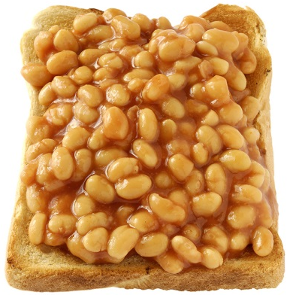

Lunch box tips
Providing your child with a balanced lunchbox needn’t be stressful, try these easy tips:
- A main meal (lunch) - sandwich, wrap, roll, salad containing veggies and a protein such as chicken/tuna/egg/cheese
- A piece of fruit AND a vegetable
- Healthy snack – cheese and crackers, fruit scone, pikelet, yoghurt
- Drink – water is best!
See the parent section of the WASCA website for more great lunch box ideas and recipes
http://www.waschoolcanteens.org.au/

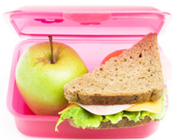

Volunteers wanted!
Do you have a spare few hours during the week? Would you like to make some new friends, have a laugh & contribute to feeding 100-200 children a healthy lunch? Have we got the job for you!!! The canteen is looking for volunteers.
- No experience necessary
- Your children/grandchildren will love seeing you at the school helping out
- Wonderful opportunity to get to know other parents from the school community
- Commitment is simply whatever time you have to give
If you are keen to help out please give (Canteen Managers name) a call on (insert phone number) or alternatively pop by the canteen anytime to put your name down on the roster and take home a job description for you to consider. We look forward to meeting you

Recipe of the term!
This terms most popular canteen item was our………… so we though we would share the recipe with you.
For example:
Apple Jaffles (Green)
Makes 10

Ingredients

- 1 x 440g can unsweetened pie apple or pears in natural juice, drained & mashed
- 1 loaf sliced raisin bread or wholemeal bread
- Ground cinnamon (optional)

Method
- Place two tablespoons of apple on one slice of bread, sprinkle with cinnamon if desired
- Cover with second slice of bread
- Cook in a heated jaffle/sandwich maker until golden brown
- Serve whole or halves for a delicious warm snack

Breakfast news
Our canteen offers some great healthy breakfast items before school. It is important to remember that children don’t need a different breakfast item every day. They simply need healthy, wholesome food and drinks like the one we offer.
- Fruit toast
- Hot chocolate
- Toast and vegemite
- Baked bean jaffles
- Fruit salad cups with yoghurt and muesli
Breakfast facts:
- One in four Australian children leaves home without breakfast due to no time, no food or not being hungry
- Skipping breakfast can mean that children potentially feel tired, irritable and can have trouble concentrating on lessons
- Breakfast means to ‘break the fast’, it is important to refuel the brain and body
with healthy choices
So call in to the canteen to see ‘what’s cooking’ for breakfast soon.

Did you know…?
Try adding a fast fact to the newsletter each week
Did you know reduced fat milk contains more calcium than full fat milk? Furthermore, reduced-fat milks are not suitable for young children under 2 years, because of their high energy needs, but reduced-fat varieties should be encouraged for older children and adolescents
Did you know the list of ingredients on product labels is listed from greatest to smallest by weight?
Did you know vitamin C improves the absorption of iron? Try adding capsicum, tomatoes and orange segments to the salad for your next BBQ.
Did you know to ensure you are eating a variety of foods, Nutrition Australia encourages Australians to eat from around 30 different food types each day?
Did you know provided they have been stored and then cooked properly, frozen vegetables provide similar levels of nutrition to fresh vegetables?
Did you know the recommended minimum levels of physical activity required for good health is at least 30 minutes of moderate-intensity physical activity on most, preferably all, days?
Did you know a medium-strength cup of tea will provide about one third as much caffeine as a cup of percolated coffee, and about two thirds as much as a cup of instant coffee?
Did you know bread was our first convenience food? It’s not surprising this is still a staple on most shopping lists.
Did you know you should keep offering new foods to kids even if the reject them at first? They need to see them several times before they look ‘familiar’.

Did you know eggs are super nutritious foods? They are a good source of protein, contain most vitamins except C, and are especially a good source of vitamin B12 and to retain nutrients eggs are best stored in the fridge in their cardboard container as it prevents odours entering the eggs.
Did you know kiwifruit has more vitamin C than an orange and is most nutrient dense fruit? They are closely followed by pawpaw, orange, mandarins & strawberries.
Did you know most Australians, especially men, eat about twice their recommended dietary intake of protein? Try having a meat-free day 1-2 days per week to decrease protein intake, increase veggie intake and it will help reduce your food costs too.
Source: Nutrition Australia

